Register sheet of receipt of periodicals
from 01.01. 20__ year to 01.01.20__

It is generated in the "Subscription" module of AILS "MegaPro".

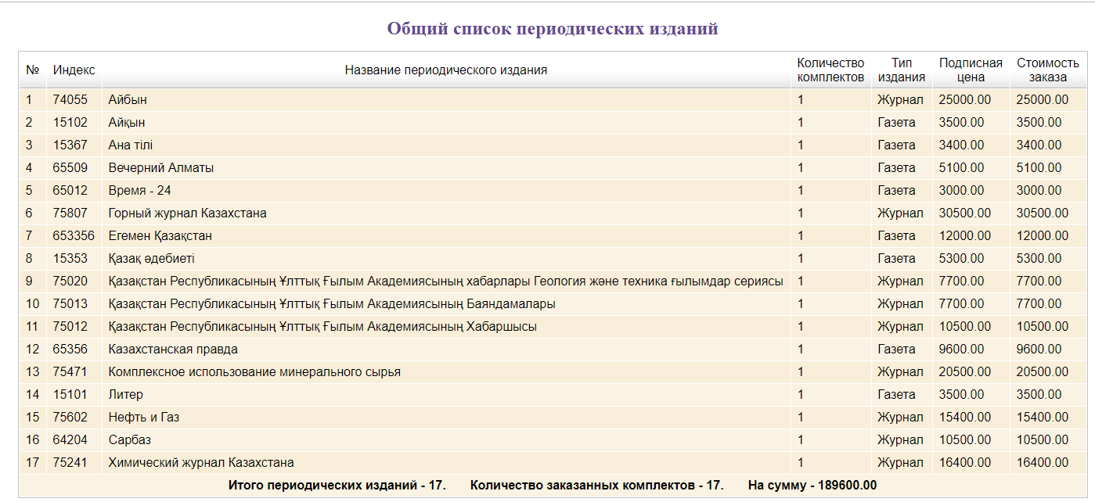
In order to ensure the processes of information resources management, the Scientific Library also uses other additional forms available in the modules of the AILS "MegaPro".

